Deductive Geometry Proof

Definition
# Source: AI Source: Provided by: [Data Path: Persons Table -> ID Column: 1, Name_En Column: Motasem Essam] -> From: [ChatGPT] on [7/25/2026]
A deductive geometry proof is a logical argument used to show that a geometric statement is necessarily true by starting with known facts and applying accepted definitions, properties, postulates, and theorems.
A deductive proof proceeds through a sequence of logical statements:
$$\boxed{\text{Given facts}→\text{Logical reasoning}→\text{Conclusion}}$$
Unlike measurement or observation, a deductive proof establishes that the conclusion must be true for every configuration satisfying the given conditions.
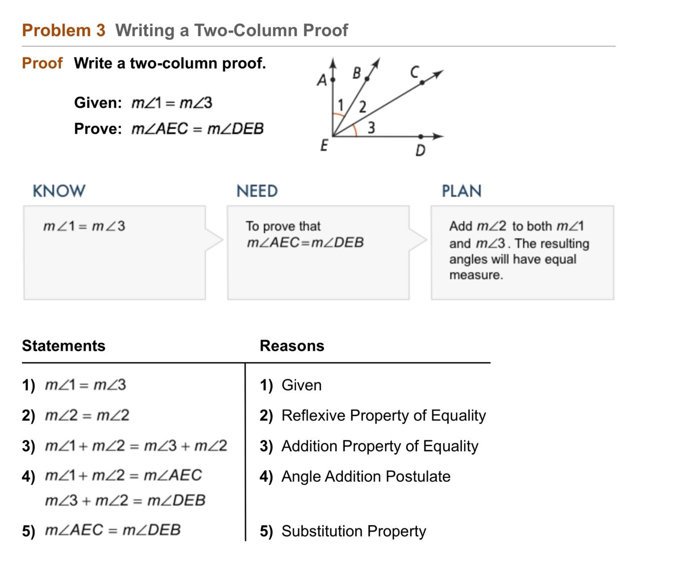
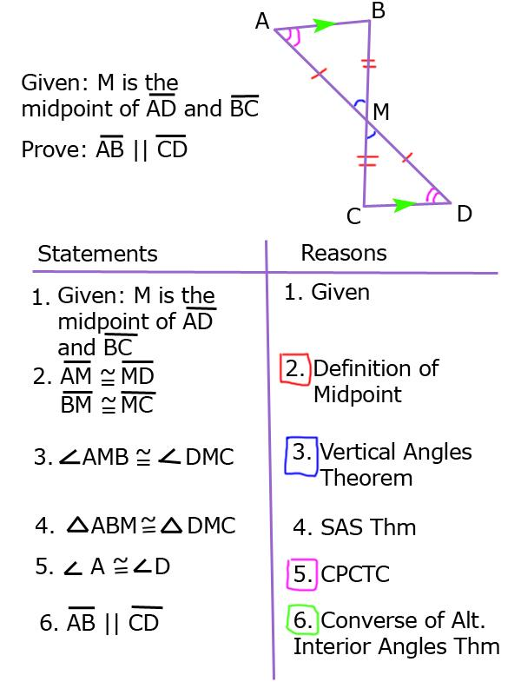
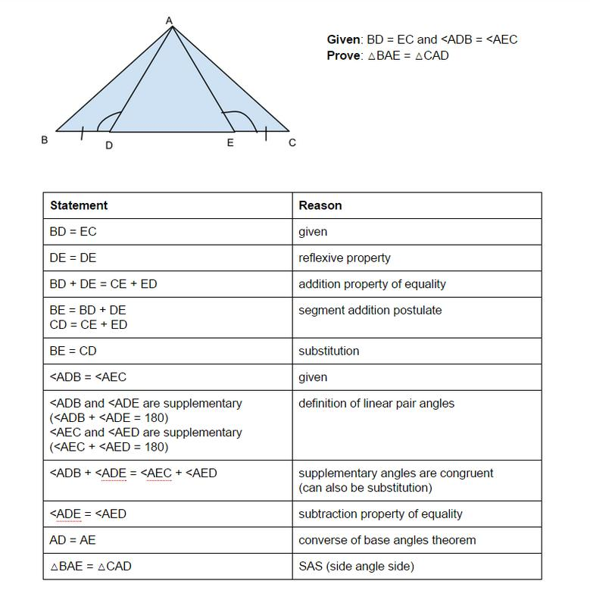
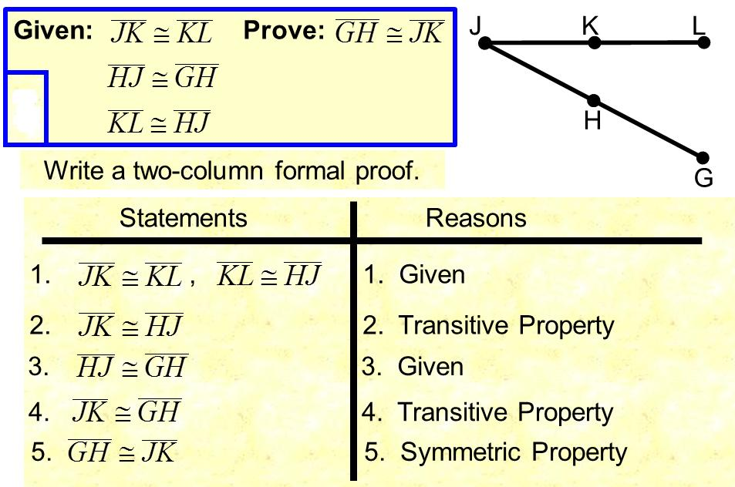
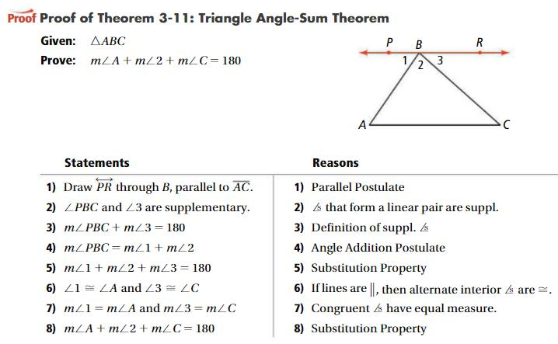
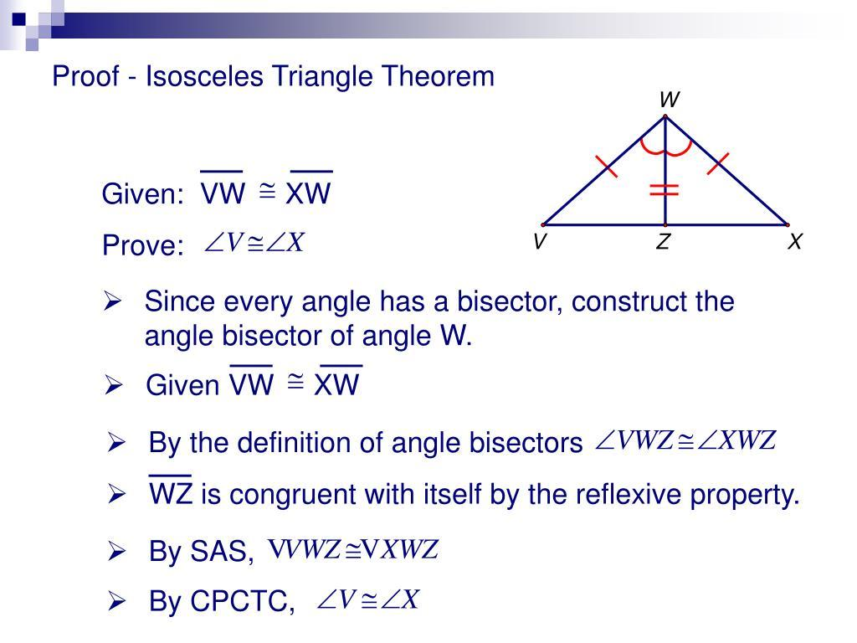

Purpose
# Source: AI Source: Provided by: [Data Path: Persons Table -> ID Column: 1, Name_En Column: Motasem Essam] -> From: [ChatGPT] on [7/25/2026]
Deductive geometry proofs are used to:
- Establish that a geometric statement is true.
- Explain why a theorem works.
- Derive new conclusions from known facts.
- Verify relationships between geometric figures.
- Develop rigorous mathematical reasoning.
- Distinguish logical proof from measurement or visual observation.

Basic Structure of a Deductive Proof
# Source: AI Source: Provided by: [Data Path: Persons Table -> ID Column: 1, Name_En Column: Motasem Essam] -> From: [ChatGPT] on [7/25/2026]
A typical deductive proof contains:
- Given — information provided in the problem.
- Prove — the statement that must be established.
- Diagram — a visual representation of the configuration.
- Statements — logical mathematical claims.
- Reasons — definitions, postulates, properties, or theorems supporting each statement.
- Conclusion — the statement that has been proved.
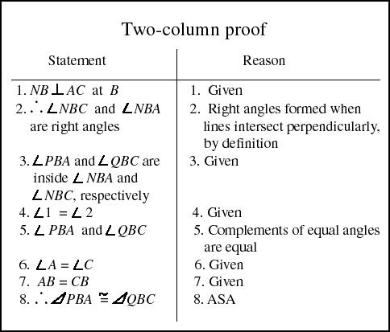
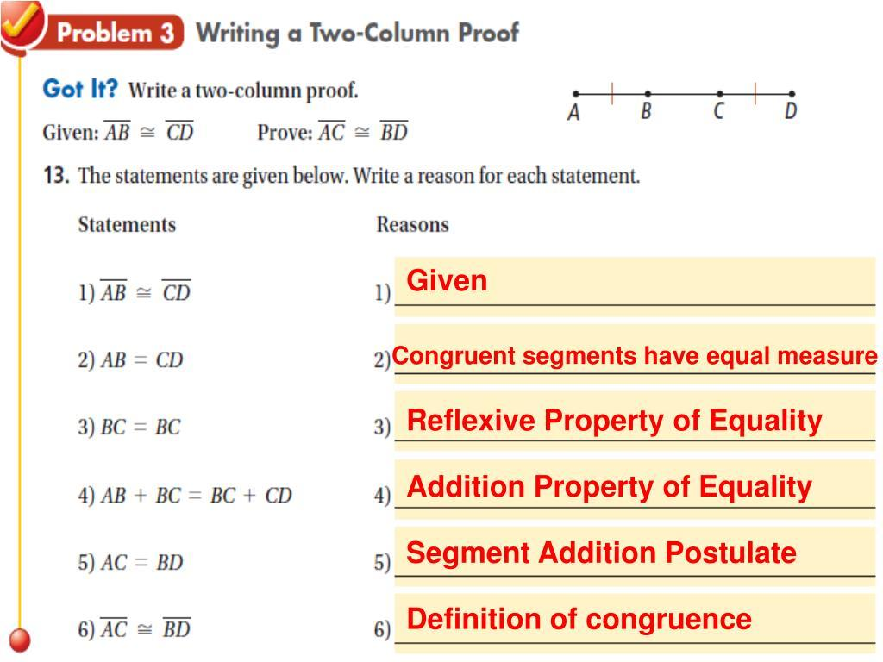
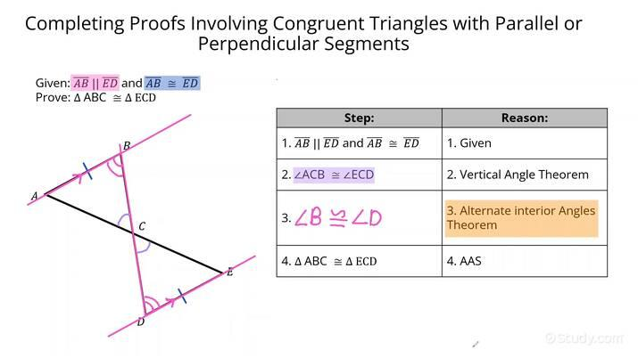
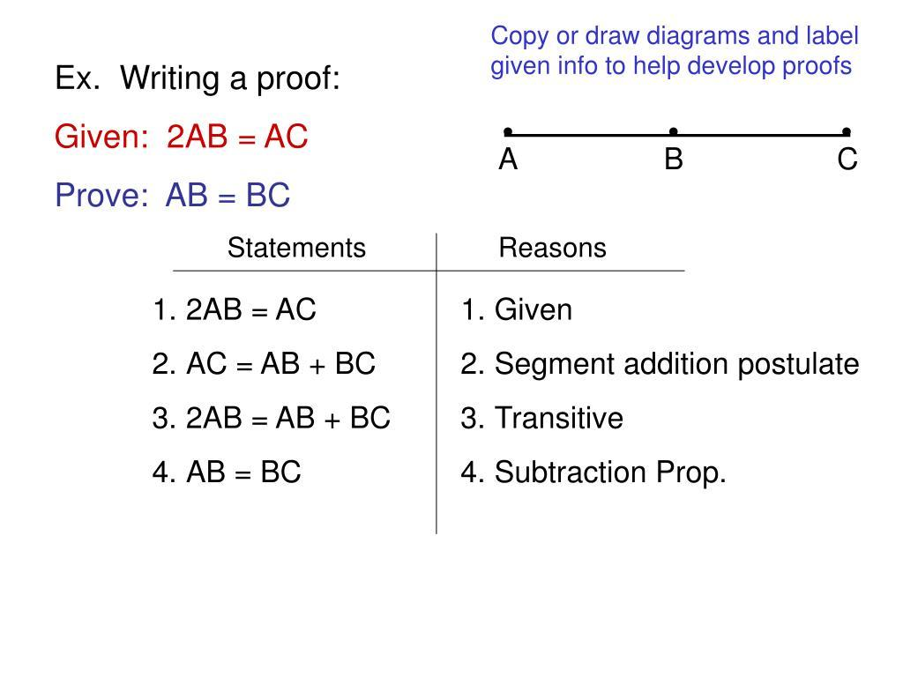

Example of the Structure
# Source: AI Source: Provided by: [Data Path: Persons Table -> ID Column: 1, Name_En Column: Motasem Essam] -> From: [ChatGPT] on [7/25/2026]
Given
$M$is the midpoint of $\overset{‾}{AB}$.
Prove
$$AM=MB$$
Proof
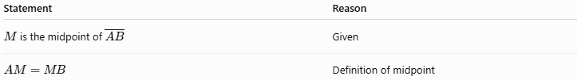
Statement | Reason
$M$is the midpoint of $\overset{‾}{AB}$ | Given
$$AM=MB$$ | Definition of midpoint
Therefore:
$$\boxed{AM=MB}$$
This is a simple deductive proof because the conclusion follows directly from the definition of midpoint.

Fundamental Elements

1. Given
# Source: AI Source: Provided by: [Data Path: Persons Table -> ID Column: 1, Name_En Column: Motasem Essam] -> From: [ChatGPT] on [7/25/2026]
The given information provides the starting facts.
Example:
$$AB=BC$$
or:
$$M\text{ is the midpoint of }\overset{‾}{AB}$$

2. Prove
# Source: AI Source: Provided by: [Data Path: Persons Table -> ID Column: 1, Name_En Column: Motasem Essam] -> From: [ChatGPT] on [7/25/2026]
The prove statement specifies what must be demonstrated.
Example:
$$∠A=∠C$$

3. Definitions
# Source: AI Source: Provided by: [Data Path: Persons Table -> ID Column: 1, Name_En Column: Motasem Essam] -> From: [ChatGPT] on [7/25/2026]
Definitions provide precise meanings that can be used as reasons.
For example, the definition of a midpoint states:
$$M\text{ is the midpoint of }\overset{‾}{AB}$$
if and only if:
$$\boxed{AM=MB}$$
Therefore, "definition of midpoint" can justify the statement $AM=MB$.

4. Postulates
# Source: AI Source: Provided by: [Data Path: Persons Table -> ID Column: 1, Name_En Column: Motasem Essam] -> From: [ChatGPT] on [7/25/2026]
A postulate is a mathematical statement accepted without proof.
Examples include basic principles involving:
- Points
- Lines
- Angles
- Congruence
- Construction
Postulates provide foundational reasoning for geometric proofs.

5. Theorems
# Source: AI Source: Provided by: [Data Path: Persons Table -> ID Column: 1, Name_En Column: Motasem Essam] -> From: [ChatGPT] on [7/25/2026]
A theorem is a statement that has already been established through proof.
Examples:
- Segment Addition Theorem
- Angle Addition Theorem
- Vertical Angle Theorem
- Triangle Angle Sum Theorem
- Pythagorean Theorem
- Perpendicular Bisector Theorem
- Angle Bisector Theorem
A proven theorem can then be used as a reason in another proof.

Logical Chain
# Source: AI Source: Provided by: [Data Path: Persons Table -> ID Column: 1, Name_En Column: Motasem Essam] -> From: [ChatGPT] on [7/25/2026]
A deductive proof can be viewed as a chain:
$$\boxed{\text{Given}→\text{Definition}→\text{Property}→\text{Theorem}→\text{Conclusion}}$$
Every step must follow logically from previously established information.

Example: Perpendicular Bisector
# Source: AI Source: Provided by: [Data Path: Persons Table -> ID Column: 1, Name_En Column: Motasem Essam] -> From: [ChatGPT] on [7/25/2026]
Given
Line $l$ is the perpendicular bisector of $\overset{‾}{AB}$, intersecting it at $M$.
Prove
$$AM=MB$$
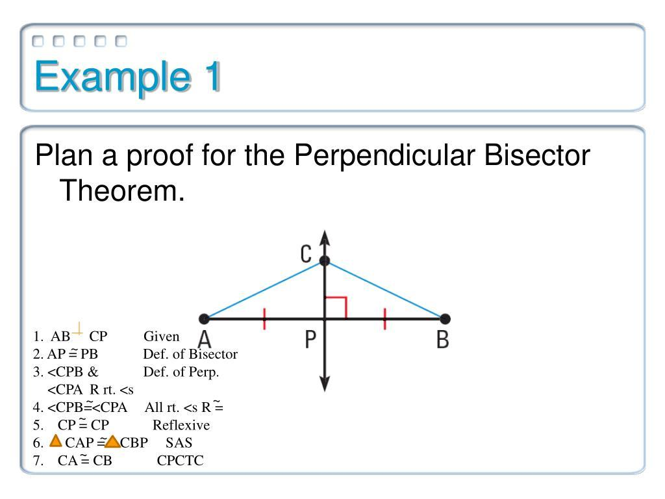
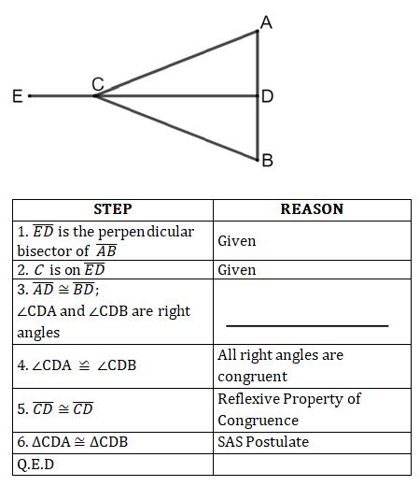
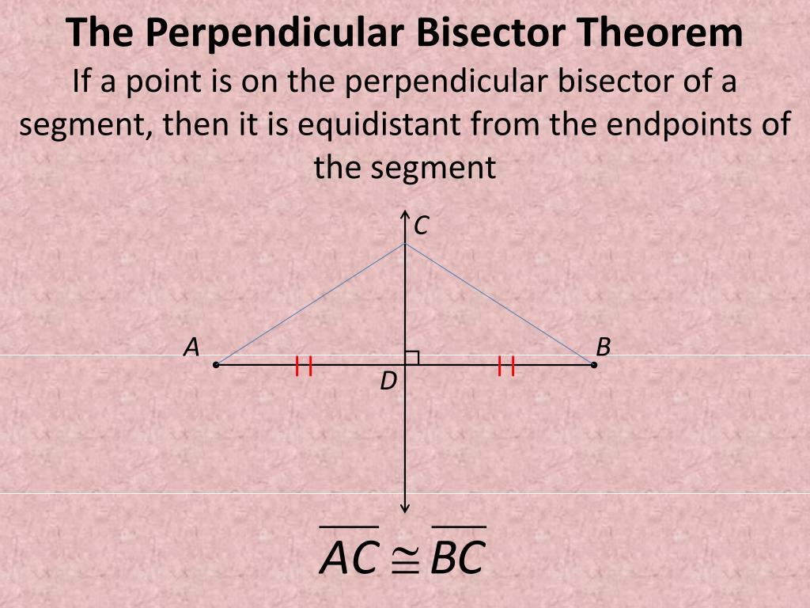
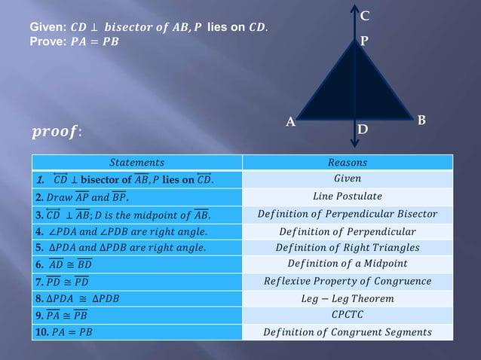
Proof
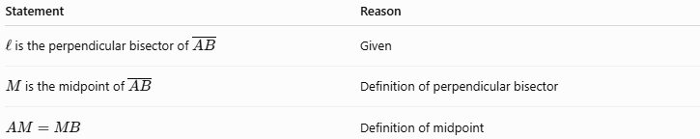
Statement | Reason
$l$is the perpendicular bisector of $\overset{‾}{AB}$ | Given
$M$is the midpoint of $\overset{‾}{AB}$ | Definition of perpendicular bisector
$$AM=MB$$ | Definition of midpoint
Therefore:
$$\boxed{AM=MB}$$

Example: Vertical Angles
# Source: AI Source: Provided by: [Data Path: Persons Table -> ID Column: 1, Name_En Column: Motasem Essam] -> From: [ChatGPT] on [7/25/2026]
Suppose two lines intersect at $O$.
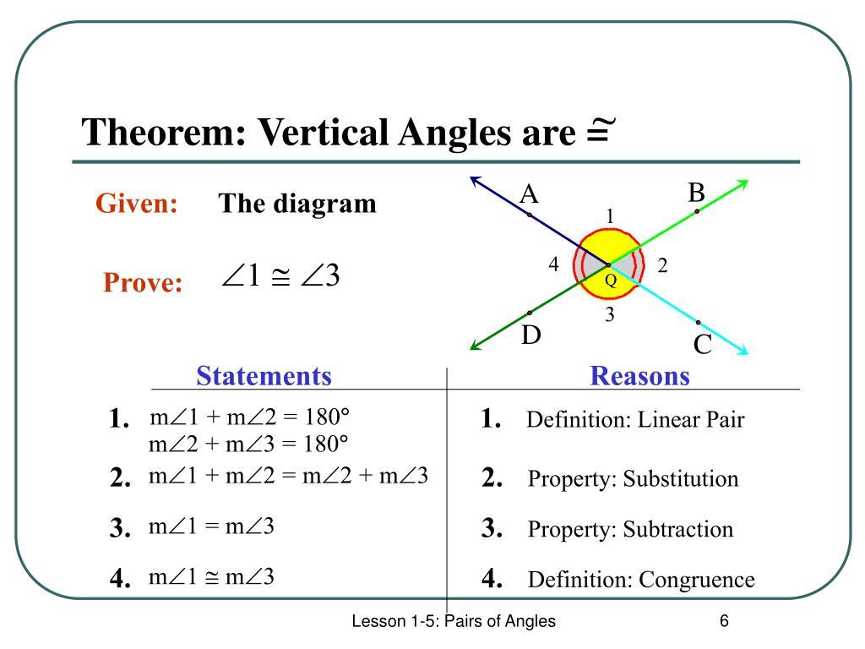
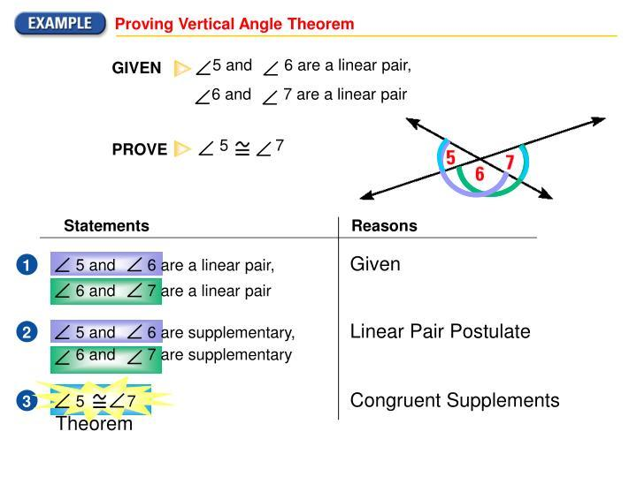
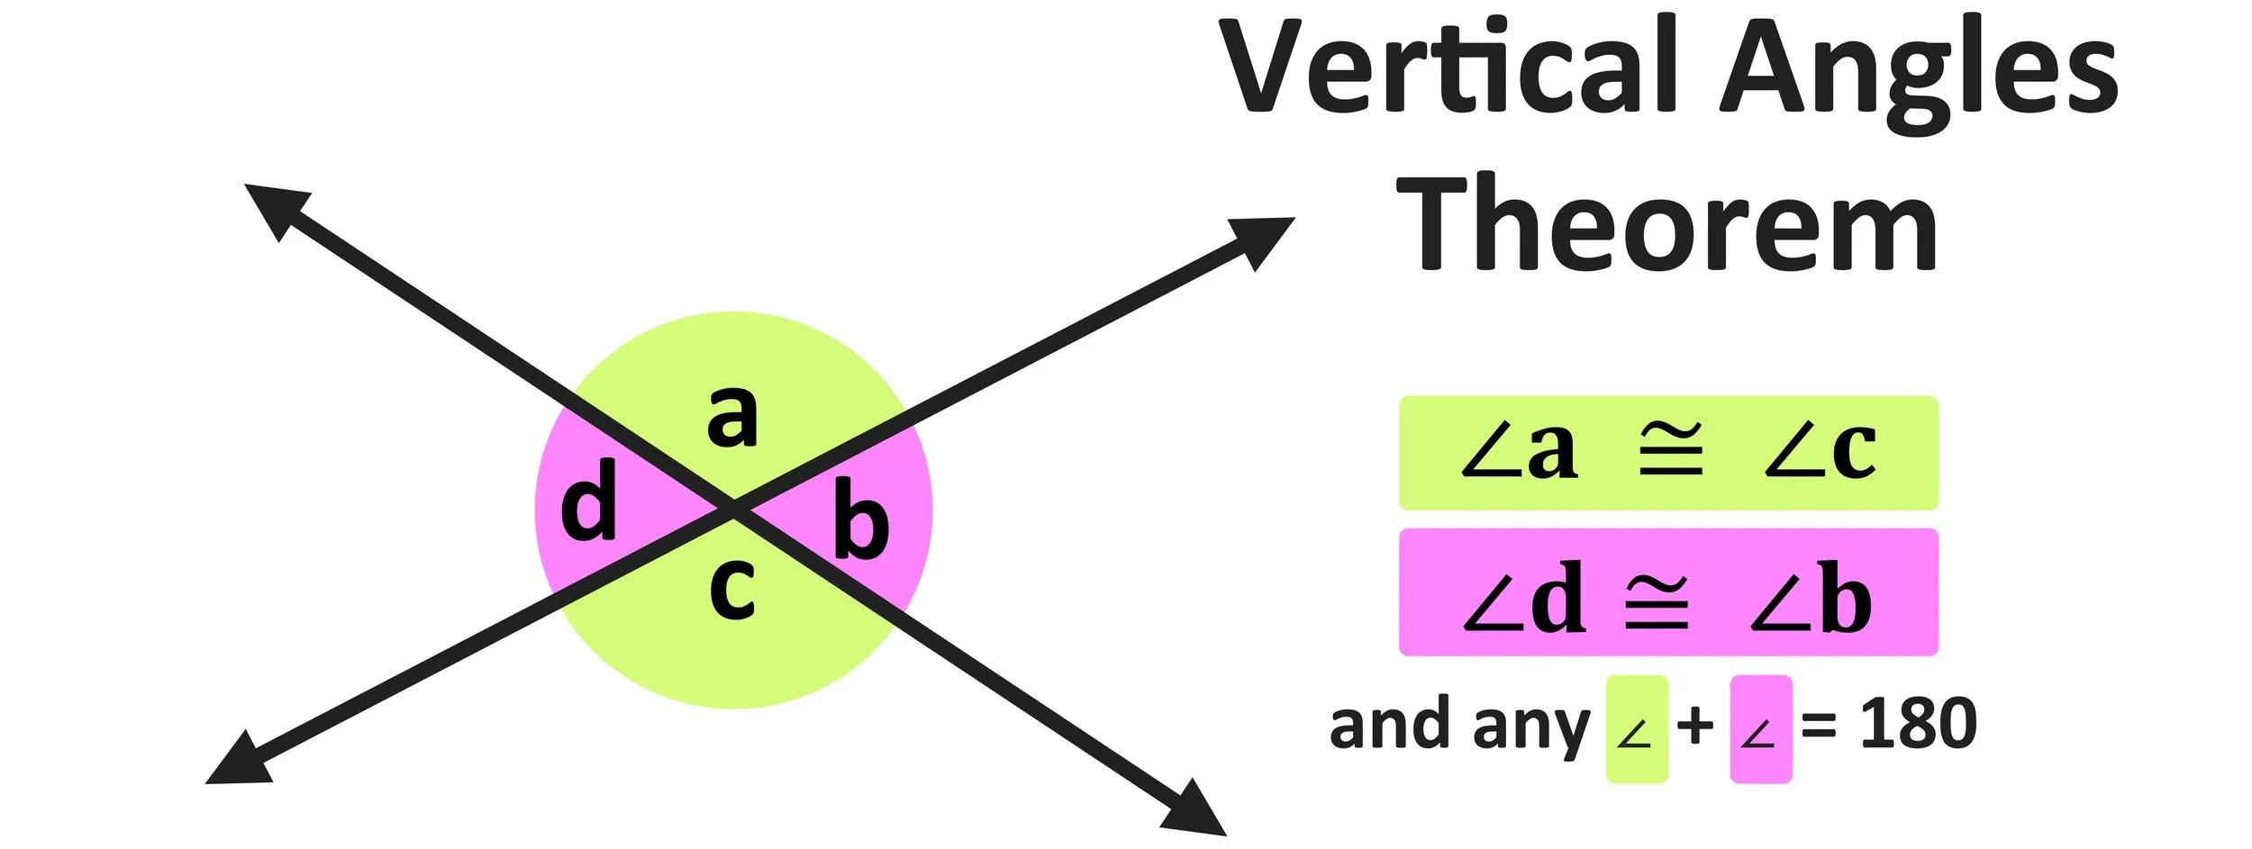
Prove
$$∠AOC=∠BOD$$
Proof
Because $A,O,B$are collinear:
$$∠AOC+∠COB={180}^{∘}$$
By the Linear Pair Theorem.
Also:
$$∠COB+∠BOD={180}^{∘}$$
Therefore:
$$∠AOC+∠COB=∠COB+∠BOD$$
Subtract $∠COB$from both sides:
$$\boxed{∠AOC=∠BOD}$$
Thus, the vertical angles are congruent.

Two-Column Proof
# Source: AI Source: Provided by: [Data Path: Persons Table -> ID Column: 1, Name_En Column: Motasem Essam] -> From: [ChatGPT] on [7/25/2026]
The two-column proof is one of the most common formats for deductive geometry.
It consists of:
Statements | Reasons
Mathematical statements | Justifications for the statements
For example:
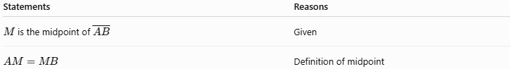
Statements | Reasons
$M$is the midpoint of $\overset{‾}{AB}$ | Given
$$AM=MB$$ | Definition of midpoint
The left column answers:
What is true?
The right column answers:
Why is it true?

Paragraph Proof
# Source: AI Source: Provided by: [Data Path: Persons Table -> ID Column: 1, Name_En Column: Motasem Essam] -> From: [ChatGPT] on [7/25/2026]
A deductive proof does not have to use two columns.
A paragraph proof presents the same logical reasoning in sentences.
Example
Since $M$is the midpoint of $\overset{‾}{AB}$, the definition of midpoint tells us that $AM=MB$. Therefore, the two segments are congruent.
The reasoning is the same as the two-column proof.

Flow Proof
# Source: AI Source: Provided by: [Data Path: Persons Table -> ID Column: 1, Name_En Column: Motasem Essam] -> From: [ChatGPT] on [7/25/2026]
A flow proof represents the logical relationships using boxes and arrows.
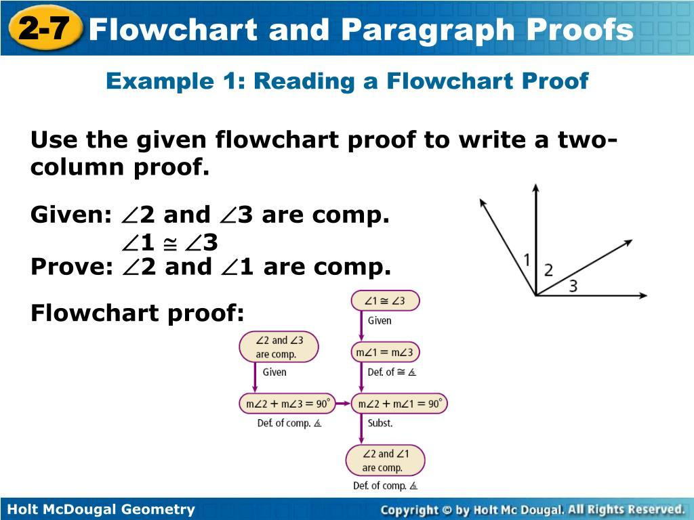
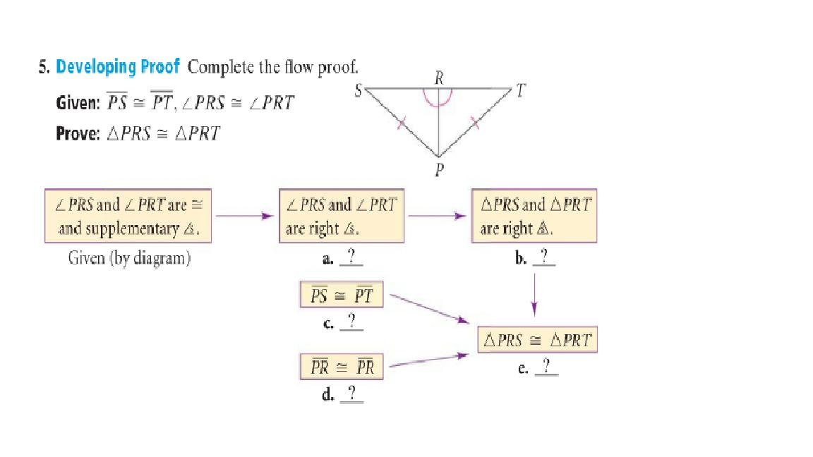
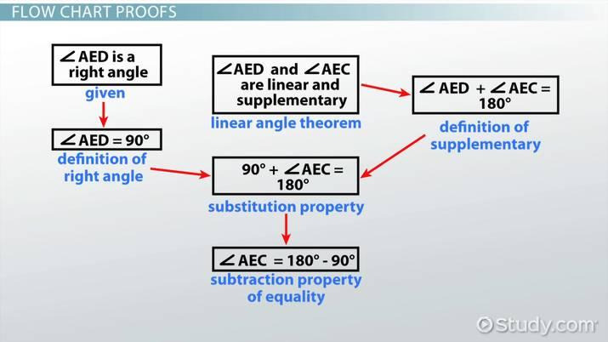
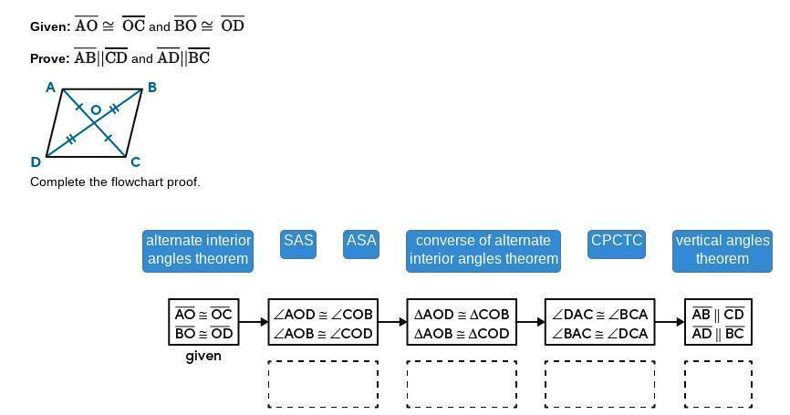
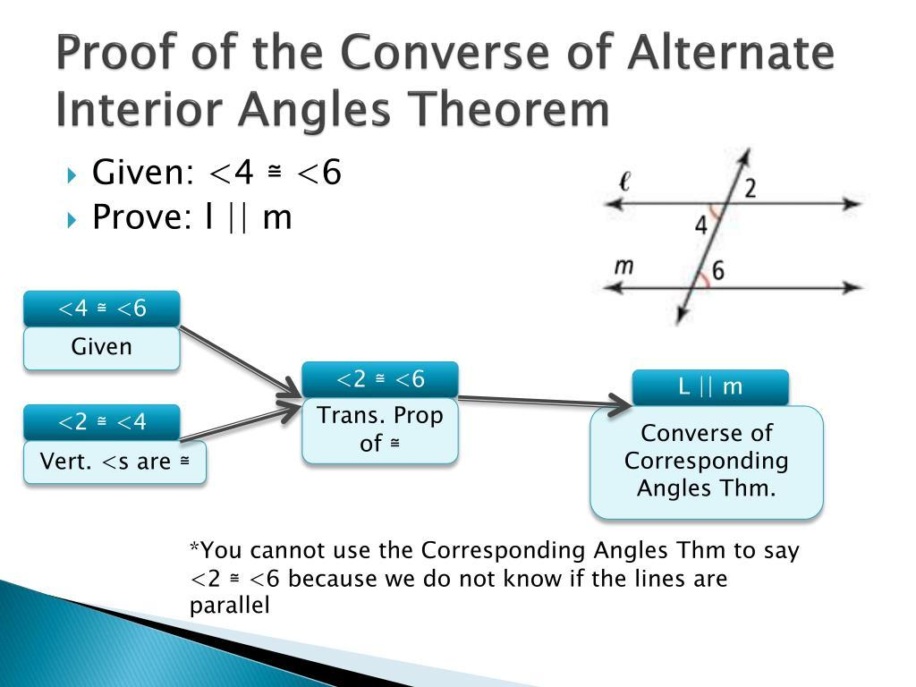
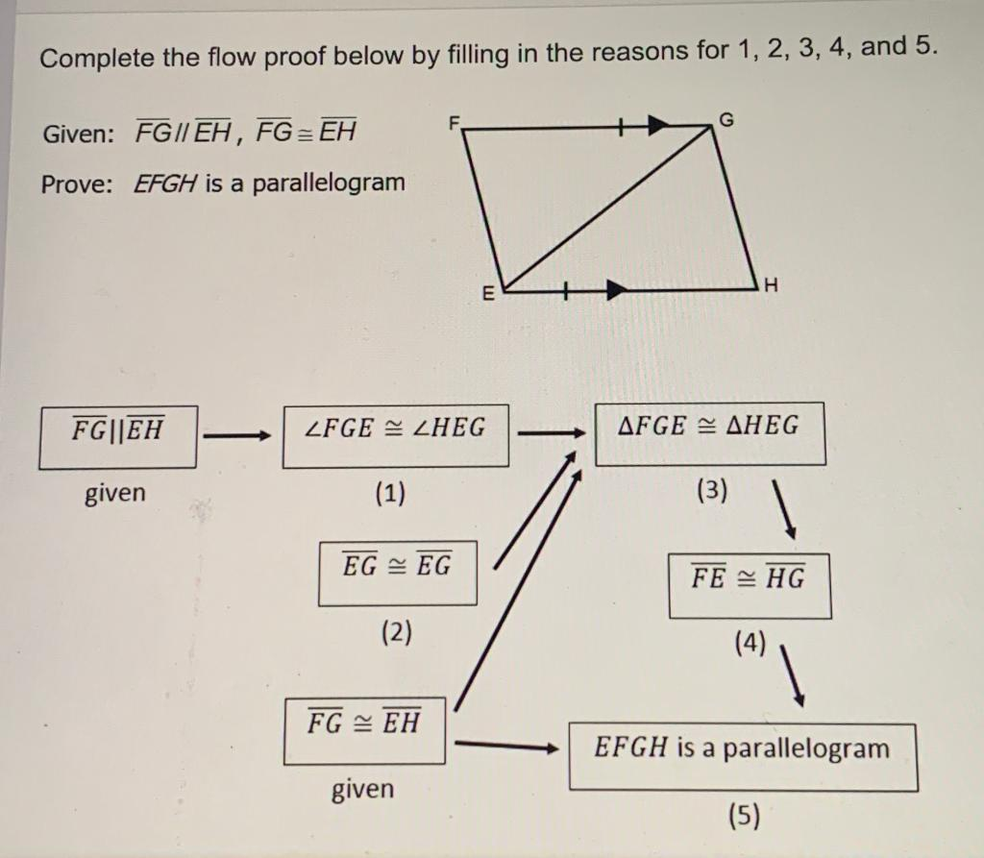
For example:
$$M\text{ is midpoint} \\ ↓ \\ AM=MB \\ ↓ \\ \overset{‾}{AM}≅\overset{‾}{MB}$$
This format emphasizes the logical flow of the argument.

Common Reasons Used in Geometry Proofs
# Source: AI Source: Provided by: [Data Path: Persons Table -> ID Column: 1, Name_En Column: Motasem Essam] -> From: [ChatGPT] on [7/25/2026]
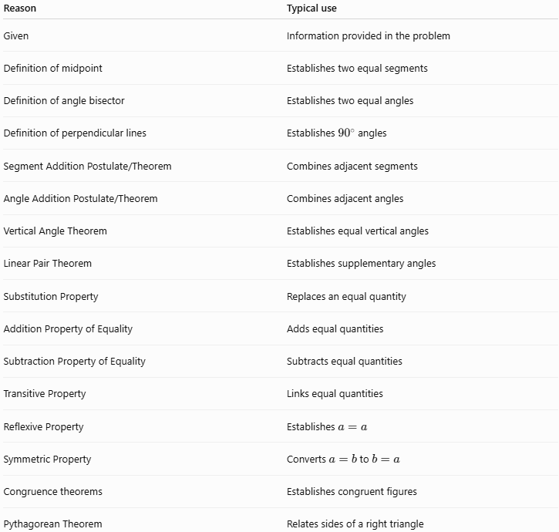
Reason | Typical use
Given | Information provided in the problem
Definition of midpoint | Establishes two equal segments
Definition of angle bisector | Establishes two equal angles
Definition of perpendicular lines | Establishes ${90}^{∘}$angles
Segment Addition Postulate/Theorem | Combines adjacent segments
Angle Addition Postulate/Theorem | Combines adjacent angles
Vertical Angle Theorem | Establishes equal vertical angles
Linear Pair Theorem | Establishes supplementary angles
Substitution Property | Replaces an equal quantity
Addition Property of Equality | Adds equal quantities
Subtraction Property of Equality | Subtracts equal quantities
Transitive Property | Links equal quantities
Reflexive Property | Establishes $a=a$
Symmetric Property | Converts $a=b$to $b=a$
Congruence theorems | Establishes congruent figures
Pythagorean Theorem | Relates sides of a right triangle

Example: Using the Transitive Property
# Source: AI Source: Provided by: [Data Path: Persons Table -> ID Column: 1, Name_En Column: Motasem Essam] -> From: [ChatGPT] on [7/25/2026]
Suppose:
$$AB=BC$$
and:
$$BC=CD$$
Then:
$$AB=CD$$
because of the Transitive Property of Equality.
The deductive chain is:
$$AB=BC \\ BC=CD$$
therefore:
$$\boxed{AB=CD}$$

Example: Triangle Proof
# Source: AI Source: Provided by: [Data Path: Persons Table -> ID Column: 1, Name_En Column: Motasem Essam] -> From: [ChatGPT] on [7/25/2026]
Suppose $△ABC$is isosceles with:
$$AB=AC$$
Prove
$$∠B=∠C$$
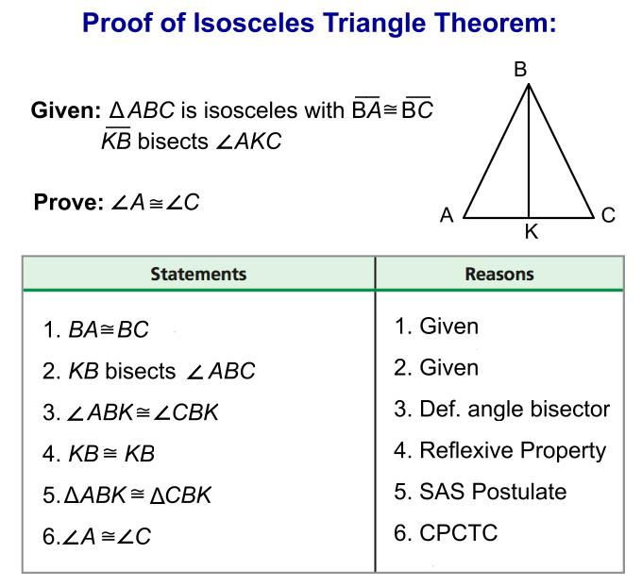
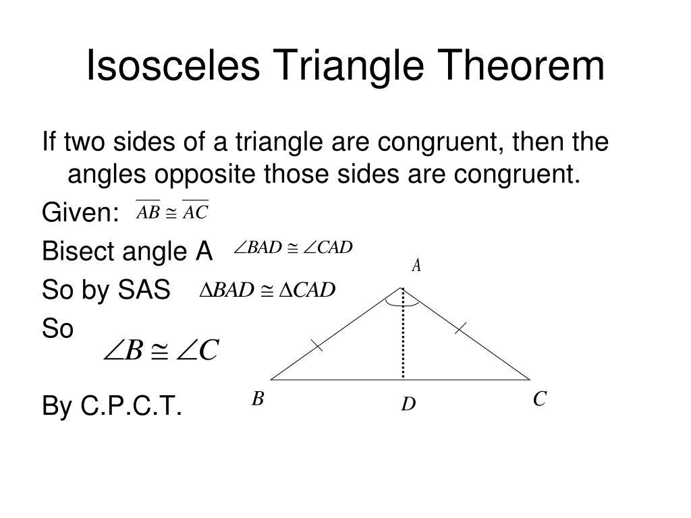
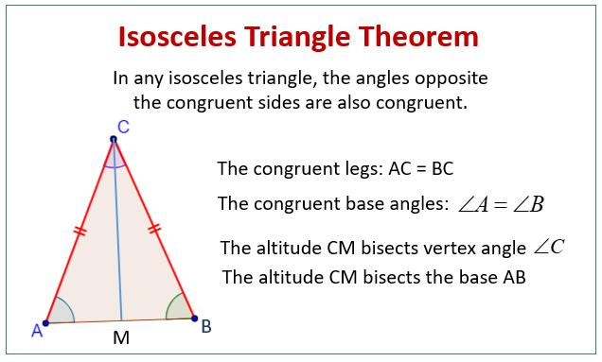
A standard proof can use a congruence argument.
Draw angle bisector $AD$from $A$.
Then:
$$∠BAD=∠DAC$$
because $AD$is an angle bisector.
Also:
$$AB=AC$$
because the triangle is isosceles.
And:
$$AD=AD$$
by the Reflexive Property.
Therefore:
$$△ABD≅△ACD$$
by SAS.
Corresponding parts are congruent, so:
$$\boxed{∠B=∠C}$$
This demonstrates how several previously established facts can be combined to prove a new result.

Deductive vs. Inductive Reasoning
# Source: AI Source: Provided by: [Data Path: Persons Table -> ID Column: 1, Name_En Column: Motasem Essam] -> From: [ChatGPT] on [7/25/2026]
These are important to distinguish.
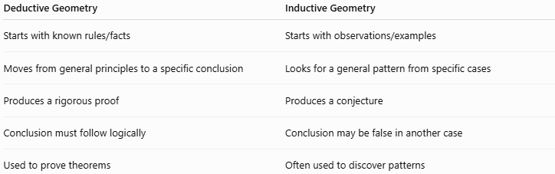
Deductive Geometry | Inductive Geometry
Starts with known rules/facts | Starts with observations/examples
Moves from general principles to a specific conclusion | Looks for a general pattern from specific cases
Produces a rigorous proof | Produces a conjecture
Conclusion must follow logically | Conclusion may be false in another case
Used to prove theorems | Often used to discover patterns
Example
Measure several triangles and observe that their angle sums are ${180}^{∘}$.
That is inductive reasoning.
Using established geometric principles to prove:
$$\boxed{∠A+∠B+∠C={180}^{∘}}$$
is deductive reasoning.

Proof vs. Measurement
# Source: AI Source: Provided by: [Data Path: Persons Table -> ID Column: 1, Name_En Column: Motasem Essam] -> From: [ChatGPT] on [7/25/2026]
A diagram can appear to show that two segments are equal, but visual appearance alone is not proof.
For example, two segments may look equal:
$$AB≈CD$$
but measurement only gives evidence.
A deductive proof establishes:
$$\boxed{AB=CD}$$
from logical premises.
Therefore:
A diagram illustrates a proof; it does not replace the proof.

Characteristics of a Valid Deductive Proof
# Source: AI Source: Provided by: [Data Path: Persons Table -> ID Column: 1, Name_En Column: Motasem Essam] -> From: [ChatGPT] on [7/25/2026]
A valid proof should:
- Begin with accepted information.
- Use correct definitions.
- Use valid mathematical properties.
- Use previously proven theorems correctly.
- Make each logical step clear.
- Avoid unsupported assumptions.
- Reach the required conclusion.

Common Errors
# Source: AI Source: Provided by: [Data Path: Persons Table -> ID Column: 1, Name_En Column: Motasem Essam] -> From: [ChatGPT] on [7/25/2026]
1. Assuming from the Diagram
A line may look perpendicular, but you cannot conclude:
$$AB⊥CD$$
unless it is given or proved.
2. Assuming Equal Lengths
Two segments may look equal, but appearance does not establish:
$$AB=CD$$
3. Circular Reasoning
You cannot use the statement you are trying to prove as a reason for proving itself.
4. Missing Justification
Every important step should have a valid reason.
5. Misusing a Theorem
A theorem must be applied only when its conditions are satisfied.

Relationship with Geometry Theorems
# Source: AI Source: Provided by: [Data Path: Persons Table -> ID Column: 1, Name_En Column: Motasem Essam] -> From: [ChatGPT] on [7/25/2026]
Deductive proofs are the foundation through which geometry develops its theorems.
The general structure is:
$$\boxed{\text{Definitions + Postulates}→\text{Proofs}→\text{Theorems}}$$
Then those theorems become tools for proving further results.
For example:
$$\text{Definitions}→\text{Perpendicular Bisector Theorem}→\text{Circumcenter Properties}$$

Applications
# Source: AI Source: Provided by: [Data Path: Persons Table -> ID Column: 1, Name_En Column: Motasem Essam] -> From: [ChatGPT] on [7/25/2026]
Deductive geometry is used in:
- Mathematical theorem proving
- Architecture
- Engineering
- Computer graphics
- CAD
- Robotics
- Surveying
- Structural design
- Computer vision
- Geometric algorithms

Advantages
# Source: AI Source: Provided by: [Data Path: Persons Table -> ID Column: 1, Name_En Column: Motasem Essam] -> From: [ChatGPT] on [7/25/2026]
- Provides rigorous justification.
- Establishes certainty rather than relying on appearance.
- Creates a logical mathematical framework.
- Allows known theorems to be used to prove new results.
- Helps identify relationships between geometric concepts.
- Develops mathematical reasoning and problem-solving skills.

Limitations
# Source: AI Source: Provided by: [Data Path: Persons Table -> ID Column: 1, Name_En Column: Motasem Essam] -> From: [ChatGPT] on [7/25/2026]
- A proof can be invalid if even one logical step is unjustified.
- Complex configurations can require many steps.
- Diagrams can sometimes make relationships difficult to visualize.
- A proof establishes a mathematical conclusion only when its assumptions and reasoning are valid.

Relationship with Related Concepts
# Source: AI Source: Provided by: [Data Path: Persons Table -> ID Column: 1, Name_En Column: Motasem Essam] -> From: [ChatGPT] on [7/25/2026]
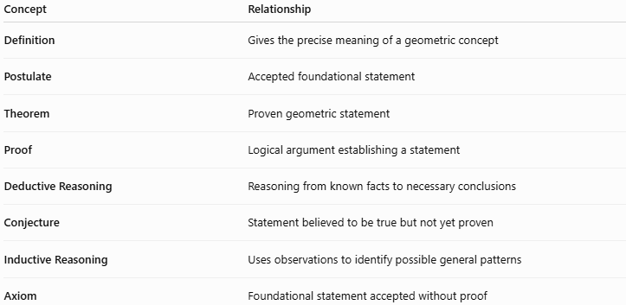
Concept | Relationship
Definition | Gives the precise meaning of a geometric concept
Postulate | Accepted foundational statement
Theorem | Proven geometric statement
Proof | Logical argument establishing a statement
Deductive Reasoning | Reasoning from known facts to necessary conclusions
Conjecture | Statement believed to be true but not yet proven
Inductive Reasoning | Uses observations to identify possible general patterns
Axiom | Foundational statement accepted without proof

Key Points
# Source: AI Source: Provided by: [Data Path: Persons Table -> ID Column: 1, Name_En Column: Motasem Essam] -> From: [ChatGPT] on [7/25/2026]
- Deductive geometry proof establishes a geometric statement through logical reasoning.
- It starts with givens, definitions, postulates, and previously proven theorems.
- Every important step requires a valid reason.
- Common formats include:
  - Two-column proof
  - Paragraph proof
  - Flow proof
- A diagram helps illustrate the configuration but does not constitute proof by itself.
- Deductive reasoning produces a conclusion that must be true whenever the assumptions are satisfied.
- Geometry theorems are established through deductive proofs.

Conclusion
# Source: AI Source: Provided by: [Data Path: Persons Table -> ID Column: 1, Name_En Column: Motasem Essam] -> From: [ChatGPT] on [7/25/2026]
Deductive geometry proof is the systematic process of proving that a geometric statement is necessarily true by connecting known facts through valid logical reasoning. It forms the foundation of formal geometry, connecting definitions, postulates, properties, and theorems into a rigorous chain of reasoning.

